CHAPTER 6

FLOOR SINKS,

SANITARY FLOOR AREA AND INDIRECT WASTE DRAINS



FLOOR SINKS

1. Sanitary floor sinks are used to receive surface drainage in areas where sanitation is a priority.
   * + 1. Typical applications are:
          1. Institutional kitchens
          2. Hospitals
          3. Drain indirect waste from various sinks and lavatories, condensate drains and other equipment.
       2. Bodies are available in:
          1. Porcelain enamel coated cast iron

FS1520, FS1530, FS1720, FS1730, FS1740, FS1750, FS1760 Series

Available in a square or round top.

Available in standard body and anchor flange (-FL) bodies.

All anchor flange bodies come standard with membrane clamps installed.

Standard Porcelain coated grates are not designed for foot traffic.

Optional Nickel Bronze (-1) and stainless steel (-3) top assemblies available.

The top assembly includes a grate and frame that fit over the floor sink.

The standard porcelain grate is removed prior to the top assembly being installed.

Top assemblies come standard as a full grate and can be converted into a ½ or ¾ grate by removing certain sections.

* + - * 1. Acid resistant epoxy (A.R.E.) coated mild steel.

FS1770 and FS1790 Series

Square top designs

Available in standard body and anchor flange (-FL) bodies.

Membrane clamps (-C) are an additional option for the flange bodies.

Come with ductile iron grates that are Special Duty load rated.

Nickel Bronze (-1) and stainless steel (-3) veneers are available.

* + - * 1. Stainless steel.

FS1920-FL, FS1930-FL, FS1940-FL Series

Square top designs.

Bodies are only supplied with anchor flange (-FL) and come standard with membrane clamps (-C).

Use either nickel bronze (-1) or stainless steel (-3) top assemblies.

* + - * 1. PVC Floor sinks

FS520-30 and FS720-30 Series

Comes standard with PVC grate.

PVC grate is cut to make a -150 or -175 grate.

Nickel bronze(-1) or stainless steel (-3) top assemblies will fit on top of the bodies.

2” connection uses the 3” body with a PVC reducer.

3” body connection fits over 3” PVC pipe and fits into 4” pipe.

Body has embossment for trap primer connection (-7) to be installed.

* + - 1. Transition bodies
         1. All the different types of bodies are offered in a transition body to allow for more types of connections.
         2. The transition body consists of a floor sink body that has a male 4” NPSM thread on the outlet to connect to a standard A1 body.

This allows a floor sink to have any type and size connection that is offered on a standard A1 body.

Even though an A1 body is available with outlet connections larger than 4”, the entire drain will only have an opening of a 4” pipe.

Trap primer connection (-7) is available on the standard A1 body.

The transition floor sink body and the A1 body are sealed using an A3-PG gasket.

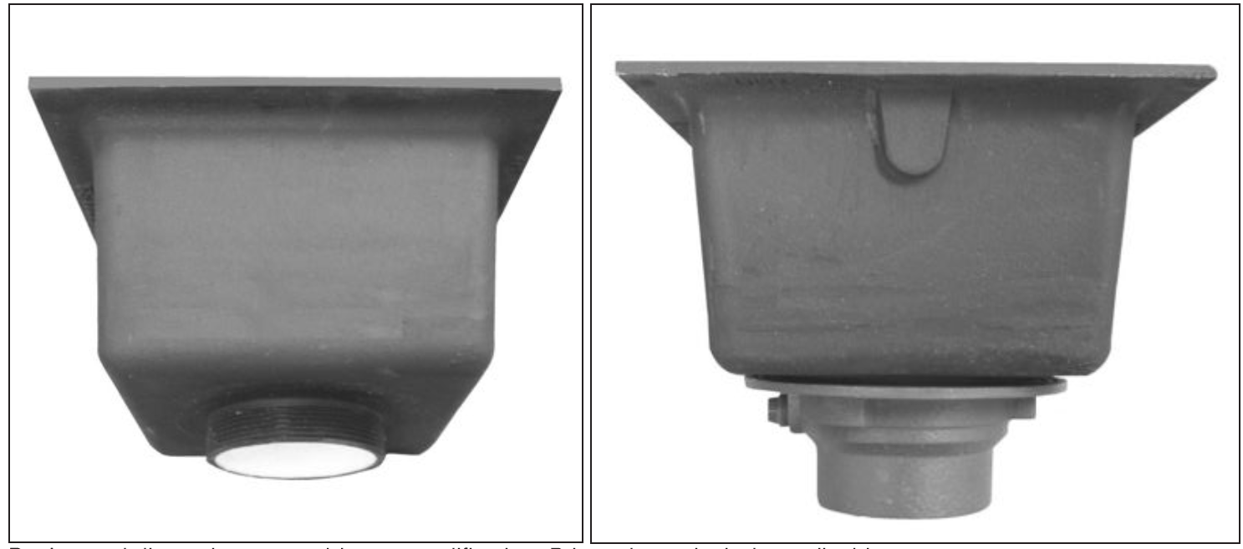

Transition floor sink body Transition floor sink assembly

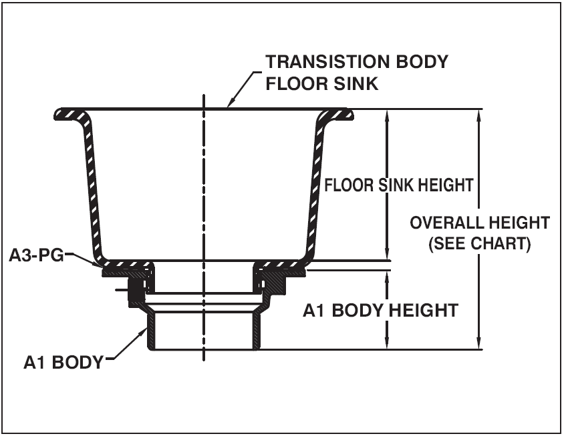

1. Typical installations

